Financial Reporting: First Take©

Current version: 7/10/17

Teaching Note: Pro Forma Financial Statements

Panera Bread Company

By Ron King (Washington University)

Table of Contents

Topic 1: Overview of this chapter 2
Topic 2: Pro forma financial statements roadmap 3
Topic 3: Information and data gathering 6
Topic 4: Get to know your target company and industry 8
Topic 5: Pro forma financial statements illustration 12
Topic 6: Resources for additional reading 55

TOPIC 1
OVERVIEW OF THIS CHAPTER

Pro forma financial statements (also known as forecasted financial statements) are forward-looking statements that summarize expected financial outcomes based on a set of assumptions about future conditions and actions. Pro forma financial statements help decision maker conduct “what if” sensitivity analysis under different sets of assumptions. Such analysis can aid in planning, budgeting, and valuation endeavors. This teaching note (written in 2014) illustrates the process of creating a pro forma income statement and balance sheet for Panera Bread Corporation for 2015.

Pro forma financial statements (or, simply, pro formas) are used for both as internal and external purposes.

Internal to the firm use: Managers prepare pro formas when evaluating major transactions, such as when considering acquiring another business, making a major capital expenditure, restructuring major product lines, or changing the company’s capital structure (such as the incurrence of additional debt or the issuance of new equity). Pro formas quantify the impact of the possible transaction on revenue, profit, cash flow, etc. and allow management to evaluate the transaction’s merit and possible risks. In addition, management may use pro formas to create internal budgets to serve as benchmarks for compensation plans and for long-term planning under different business directions and priorities.

External use: Pro formas are used by external decision makers (such as investors, creditors, suppliers, and customers) to help model a company’s intrinsic value and its future business profile. By forecasting future revenues, operating expenses, cash flows, and capital expenditures, potential investors can gain greater insights into whether the company’s stock is undervalued, correctly valued, or overvalued. In addition, pro formas allow external decision makers to undertake sensitivity analysis to evaluate the robustness of the current business model under different assumed inputs.

Caveat: Pro forma are pervasive tools used for business planning and decision making. However, pro forma should not be considered reliable forecasts of actual future performance and financial position. Rather, the forecasting process facilitates the consideration of critical drivers and assumptions and as such represent a valuable framework to discipline decision makers’ thinking and to require that they present and justify judgments and proposed actions.

This teaching note introduces the concept of pro forma financial statements, and illustrates the steps involved in the preparation of pro forma financial statements from an external analysts’ point of view. As you would expect, there are many different methods and protocols for forecasting forward-looking financial statements.

We illustrate one approach that we think has the representative aspect of the general process to give readers a clear mental model of the process. We use Panera Bread Company as our example and we forecast an income statement (for year ending 2015) and one balance sheet for December 31, 2015.

The teaching note includes six topics and multiple exhibits to support coverage of the concepts.

TOPIC 2
INFORMATION AND DATA GATHERING

Pro formas require that decision makers make judgments about critical drivers and appropriate assumptions. Such judgments can be based on both practical experience (from personal experience in the field and by soliciting information from those who have such experience) and the study of relevant information resources (from public data sources).

In this section we list some sources of information (related to the second category) from on-line resources and the Olin Business School library.

Basic topics that you may wish to study as a starting point for your research could include:

- Company’s releases
- Annual reports, and quarterly reports:
URL: https://www.panerabread.com/en-us/company/financial-reports.html
  - Section in SEC Form 10-K:
The Letter to Shareholders, and Management Discussion and Analysis (MD&A). Note: look for explanations of a company’s markets, an outline of its short-term and long-term objectives, discussion of key risks to achieving those objectives, etc.
- Annual conference call, and quarterly conference call
URL: https://www.panerabread.com/en-us/company/investor-relations.html -> past events

- Non-company provided information
- Analysts’ reports on individual firms: Capital IQ (Standard & Poor’s): a leading provider of multi-asset class and real-time data, research and analytics.
URL: https://www.capitaliq.com/ciqdotnet/login.aspx
- White papers on firm and industies
- Analysts’ reports on industries: IBISWorld: a provider industry market research, analysis and forecasts.
URL: http://clients1.ibisworld.com.libproxy.wustl.edu/
- Additional information sources can be found in the business library at http://library.wustl.edu/units/business/databases.html

- Media reports:
  - Bloomberg Business, URL: http://www.bloomberg.com/
  - The Wall Street Journal: URL: http://www.wsj.com/
  - The New York Times: URL: http://www.nytimes.com/pages/business/index.html

- Government reports:
  - SEC Edger, URL: https://www.sec.gov/edgar/searchedgar/companysearch.html

In general, pro forma preparers benefit from an understanding of the following
- Current and expected macroeconomic factors
- Industry dynamics, including resources, capabilities, and plans of competitors, suppliers, customers, and labor issues
- Firm’s specific factors: the firm’s strategy and plans and
- Capital market expectations

This knowledge base can come from some combination of on-the-ground experience and information sources.

In the next section, we list 14 steps that provide a high-level roadmap for creating a pro forma income statement and balance sheet for Panera. This roadmap shows just one representative approach; there are many approaches to creating pro formas and the chosen approach may depend on the intended purposes of the pro formas and the knowledge the analysts have about underlying drivers and assumptions and the access to alternative (public and private) information resources.

TOPIC 4
GET TO KNOW YOUR TARGET COMPANY AND INDUSTRY
In this section we introduce Panera Bread Company.

Panera Bread, one of the largest food service companies in the United States, is a national bakery café concept with 1,880 company-owned and franchise-operated bakery cafe locations in 45 states, the District of Columbia, and Ontario, Canada. They operate under the Panera Bread®, Saint Louis Bread Co.® and Paradise Bakery & Café® trademark names. Their bakery-cafes are located in urban, suburban, strip mall, and regional mall locations. They feature high- quality food in a warm, inviting, and comfortable environment.

Segments: Panera has three business segments: (1) company bakery- cafe operations, (2) franchise operations, and (3) fresh dough and other product operations. Both company-owned bakery-cafes and franchise operations have over 900 stores. Fresh dough and other product operations segment supplies fresh dough and other products daily to most company- owned and franchise operated

Bakery-cafés: Panera’s franchisees operated approximately 51 percent of the company’s bakery-café, with a total number of 955 franchise-operated bakery-cafes as of December 30, 2014. For a typical franchise-operated bakery-café, Panera receives a franchise fee of $35,000 per café at opening, and continuing royalties, which are generally five percent of net sales per bakery-café.

Fresh dough and other product operations are within fresh dough facility system and supply chain function. Panera’s regional fresh dough facilities supply dough for fresh bread on a daily basis, along with tuna, cream, and certain produce to substantially all of the company-owned and franchise-operated bakery-cafés. Panera distribute fresh dough and produce through a leased fleet of temperature controlled trucks operated by associates.

These three segments constitute Panera’s revenue share significantly differently. Among total revenue, exhibit 11-2 shows that revenue from Bakery-Café segment constitutes the largest shares - an average of 87.58% of total revenue, and exhibit 11-1 also shows that Bakery-Café segment leads the highest growth rate - a CAGR of 14.10% from 2009 to 2014. Revenues from franchisees and fresh dough and other product sales to franchisees grew from 2009 to 2014 with CAGRs of 9.56% and 7.52% respectively.

Menu: Panera’s menu includes breakfast, lunch, dinner, and take-home. Recently, Panera also offers delivery services. In addition to dining-in services, Panera offers catering and intends to expand its catering services in 2015.

Future: In its May 2015 Annual meeting, Panera announced its strategy for its stronger future that included Panera 2.0 policy that invested in digital access, operational integration, and delivery to table services. Panera also developed its Concept Essence 2015, and innovated in food to provide good eating experience.

Industry: According to IBISWorld and Capital IQ, Panera Bread is a leading company in the industry of Bakery Cafes, which belongs to a broader industry of Specialty Food Stores. In the past year of 2014, the industry of bakery cafes had a total revenue of $8.1 billion with a profit of $446.9 million. The annual growth from 2010 to 2015 is about 7.4%, while the annual growth from 2015 to 2020 is expected to be 2.4%. Panera Bread Company is definitely a key player in this industry, with a market share of 54.2%. The second largest business player is Einstein Noah Restaurant Group, with a market share of only 6.1%, compared to 54.2%.

The key economic drivers of this industry are: consumer spending, consumer confidence index, health eating index, and per capita coffee consumption. Consumer spending measures the total amount Americans spend on services and goods in a net amount, both domestically and abroad. The more consumers spent in general, the more they are likely to spend in the bakery café industry. This ratio has kept growing after the recession, and is predicted to be increased by 3-4% in each year from 2015 to 2017, which is a peak after 2006. Consumer confidence index has been growing rapidly from 2010 to 2015 with a compounded annual growth rate (CAGR) of 12.3%. It’s predicted that it will keep relatively flat with a CAGR of 0.9% from 2015 to 2020. Health eating index measures the degree that an average American adheres to the consumption guidelines set out by the US Department of Agriculture. This index has been increasing by 0.8 percent in each year from 2009 to 2014, and is predicted to be increased by 2.6% in each year from 2014 to 2019. Considering the nature of bakery café industry, that increase can be a good news. Per capita coffee consumption trend is rather conservative, and with little increase, 0.4%, predicted for the year from 2014 to 2019.

The bakery café industry is currently in a warming-up growth cycle, and high-quality menu items and increased consumer spending will bolster revenue. IBISWorld comments that the bakery cafes industry is set to surge ahead over the next five years, though the industry may reach the saturation period toward the end of the five years to 2020. Increased consumer demand and the broader economic environment contribute to this outlook.

Competitors: The major competitors that are listed by Panera management are as following:
Einstein Noah Restaurant Group
Chipotle Mexican Grill, Inc.
Starbucks Corporation
Buffalo Wild Wings Inc.
Brinker International, Inc.
McDonald’s Corp

In the next section we provide a road map of the 14 steps we use in preparing pro forma statements.

TOPIC 2
PRO FORMA FINANCIAL STATEMENTS ROADMAP
① Forecast revenue for each segment.
Methods / inputs: trend analysis using historical data; estimates from analysts’ reports; forecasts from management.
② Forecast net income.
Methods / inputs: analyst estimates, target amounts, historical trends.
③ Forecast Cost of Goods Sold (COGS) for each segment.
Methods / inputs: analyst estimates, target amounts, historical trends.
④ Forecast selling, general, and administrative expenses.
Methods / inputs: analyst estimates, target amounts, historical trends.
⑤ Forecast total assets and individual asset item.
Methods / inputs: historical total assets turnover (TAT) ratio, newly forecasted total revenue, and historical individual asset percentage as of total assets.
⑥ Forecast total liabilities and each liability item.
Methods / inputs: historical leverage ratio (liabilities / total assets), and newly forecasted total assets, and each liability line item as a historical percentage of total liability.
⑦ Forecast total stockholders’ equity.
Methods / inputs: newly forecasted net income, and historical or predicted dividend payout ratio.
⑧ Calculate balance sheet plug to so that Assets = Liabilities + Shareholders’ equity.
⑨ Forecast depreciation and amortization expense.
Methods / inputs: the historical percentage of the expense relative to the sum of PP&E and intangibles.
⑩ Forecast pre-opening expenses.
Methods / inputs: new store opening trend, and historical expenses.
⑪ Forecast interest expense.
Methods / inputs: the historical percentage compared to long-term debt and other long-term liabilities.
⑫ Forecast other income (expense).
Methods / inputs: historical trend analysis.
⑬ Forecast income taxes and income before income taxes.
Methods / inputs: common-sized compared to net income obtained from historical data.
⑭ Close income statement by adding income statement plug.

Ratio calculation to check reasonableness of your assumptions: Once you have the pro forma income statement and balance sheet completed, we recommend that you consider the overall reasonableness of your assumptions. One way to do this is by calculating a set of ratios that you have reasonable expectations about due to historical trends or targets. Examples include operating income percentage, net income percentage, total asset turnover, ROA, ROE, etc. If these ratios diverge significantly from expectations, you may be advised to review and reconsider your pro forma assumptions.
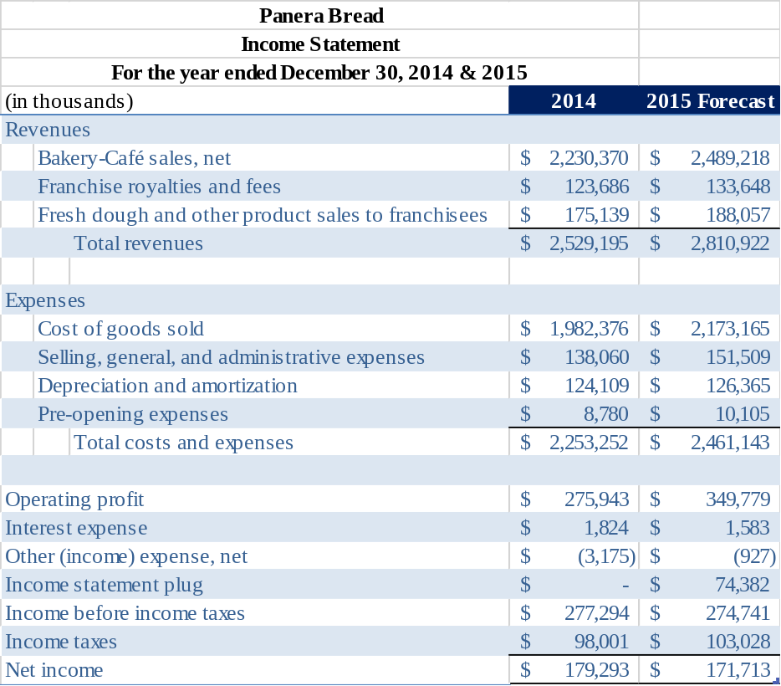
❹
⓬
❿
⓫
❾
❸
⓮
❶
❷
⓭

TAT=A/R

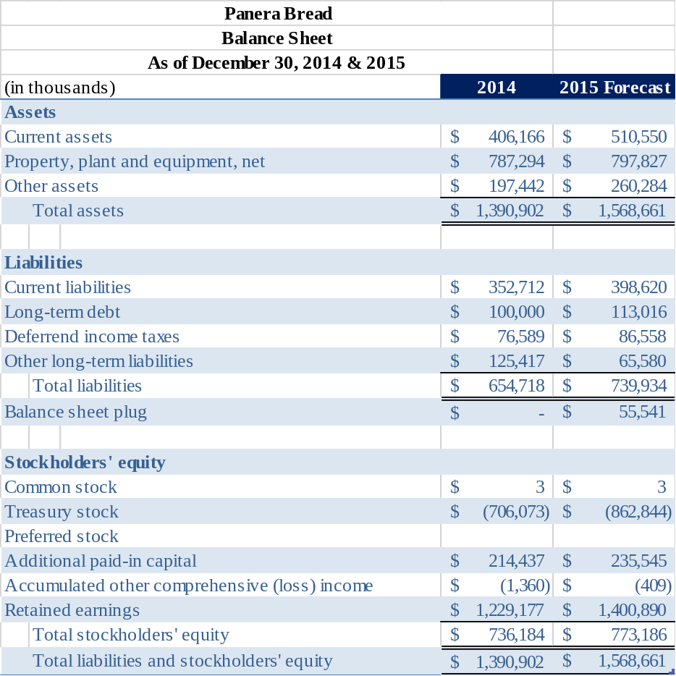
❺
❻
❼
❽
TOPIC 5
PRO FORMA FINANCIAL STATEMENTS ILLUSTRATION

Step 1: Forecast revenue for each segment and for total revenue.

In this section, we discuss how to forecast revenues for each segment, and the total revenue. Note, in this chapter, we will discuss how to create pro forma financial statements from an investor’s point of view instead of an analyst’ point of view. Therefore, we can assume that we will have analysts’ estimates on hand to create our pro forma financial statements.

The assumptions about forecasted revenue growth drive the forecasting of most other financial statement captions, making it one of the central assumptions underlying pro formas.

We use a combination of three methods to develop our forecast: (1) historical trend analysis (CAGR), (2) management guidance, and (3) analysts’ estimates. An average of the three is used to calculate estimated future revenue for each year and for each business segment of Panera. Total revenue is calculated as the sum of the three business segments.

Historical trend analysis

Management’s guidance
Investor’s
Revenue
Forecast

Analysts’ estimates

Exhibit 11-1. Revenue section from the income statement ($ in thousands)
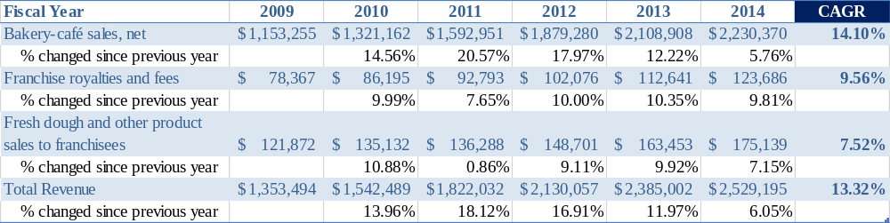

Exhibit 11-2 Segment revenue shares
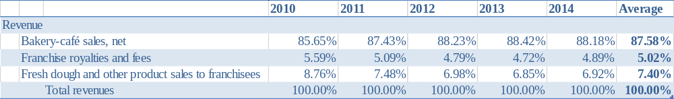

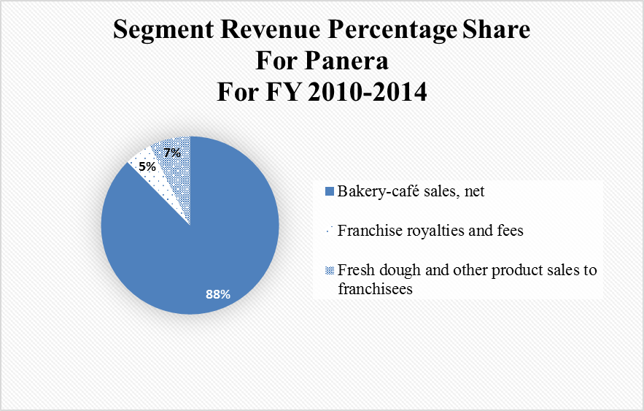

TOPIC 5
PRO FORMA FINANCIAL STATEMENTS ILLUSTRATION

Method 1: Historical trend analysis of forecasting revenue based on segments

In this section, we will discuss how to forecast Panera’s each segment’s revenue growth rate under historical trend analysis.

We start by considering Panera’s historical revenue records. In Exhibit 11-1, we compile six-year data to provide a longer historical perspective, and to show a five year growth trend. Panera’s total revenue grew from $1,353 million in fiscal year (FY) 2009 to $2,529 million in FY 2014, creating a compounded annual growth rate (CAGR) of over 13.32%. Within total revenue, bakery-café segment created a CAGR of 14.10%; franchise royalties and fees segment created a CAGR of 9.56%; fresh dough and other product sales to franchisees created a CAGR of 7.52%

Under historical trend analysis, the calculated CAGR can be applied to future years 2015, 2016, and 2017 to predict future growth in revenue. For simplicity, we will assume that FY 2015, 2016, and 2017 share a same CAGR.

Exhibit 11-3. Segment revenue growth rate forecast
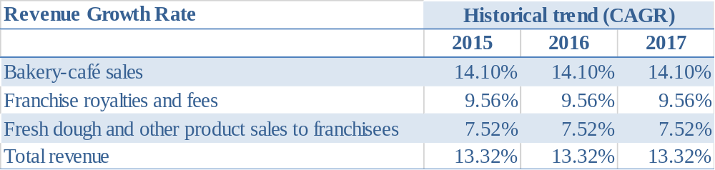

How many years of data do you need to collect?

In this case, we would like to forecast pro forma financial statements for the years from 2015 through 2017. We make predictions based on the information from the previous five years. In case that you need to forecast pro forma financial statements for a longer period, such as five years, a longer period of previous data is required, such as ten years.
TOPIC 5
PRO FORMA FINANCIAL STATEMENTS ILLUSTRATION

Method 2: Management's guidance of forecasting revenue based on segments

In this section, we will discuss how to forecast Panera’s each segment’s revenue growth rate under management’s guidance.

These estimates come from the management team of Panera directly from their annual meeting in May 2015, as they provided same-store sales growth and the total number of Bakery-Café trend as shown in exhibit 11-4 and 11-5. Since store sales growth and new store opening are the main drivers of revenue increase, it’s reasonable to forecast future revenue growth based on the two factors mentioned above.

Exhibit 11-4. Same-store sales growth.
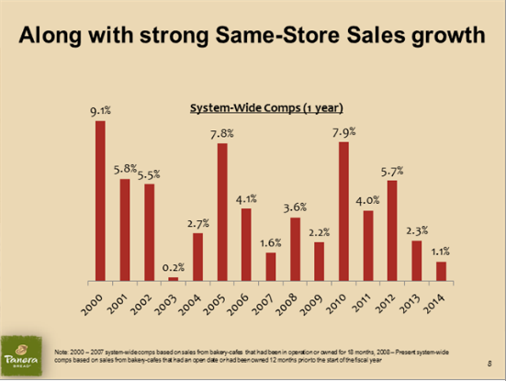
According to exhibit 11-4, same-store sales growth has an average of 4.24% throughout the years shown on the graph.

Exhibit 11-5. Store opening trend.
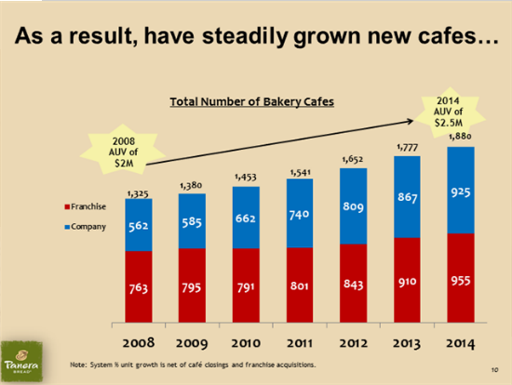

Exhibit 11-6. Number of stores growth

According to exhibit 11-5’s calculation, we have got a CAGR of 9.6% of company-owned store growth, and a CAGR of 3.74% of franchise stores growth. With all of the information above ready, we can get a total growth rate of 14.25% for Bakery-Café revenue, and a total growth rate of 8.14% for Franchise segment revenue. Since fresh dough segment provides fresh dough and other product sales to franchisees only, and fresh dough segment constitutes only 7.4% of total revenue, we will simply assume that fresh dough segment’s revenue shares a same growth rate (8.14%) as Franchise segment revenue. To sum up, Exhibit 11-7 shows our forecasted revenue growth.

Exhibit 11-7. Revenue growth rate forecasted by management guidance method
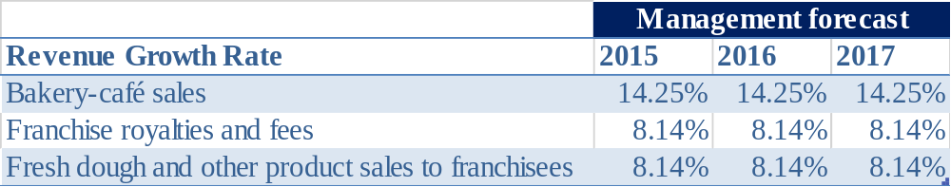
TOPIC 5
PRO FORMA FINANCIAL STATEMENTS ILLUSTRATION

Method 3: Analysts’ estimates of forecasting revenue

In this section, we will discuss how to forecast revenue based on analysts’ estimates.

These estimates come from research institutions and investment bankers. Exhibit 11-8 shows the revenue growth estimates that we have obtained from different sources.

Exhibit 11-8. Analyst forecast on revenue growth rate
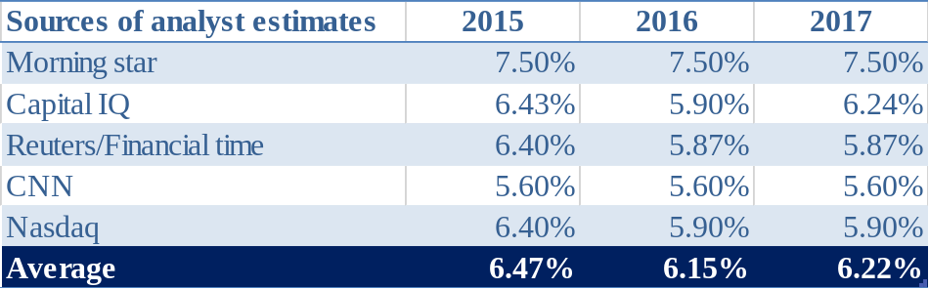

Under our current assumptions, all growth estimates are weighted equally; and when the estimate from one source covers less than three years, the last estimate is used for the rest years.

As we can see from Exhibit 11-8, morning star has the highest estimates of 7.5%, followed by Capital IQ, Reuters/Financial times, and Nasdaq who have an estimates around 6.4% on 2015 and 5.9% on 2016 and 2017. Capital IQ has a slightly higher estimate of 6.24% on 2017 compared to the other two. CNN has the lowest estimates of 6.5% in future years. Taken 2015 estimates as an example, morning star’s estimate (7.5%) is 34% higher than CNN’s estimate, and this large amount of difference shows the variance on analysis estimates and the estimates’ uncertainty.

For this method, we use an average of estimates from all sources as our final figure, as shown in Exhibit 11-9.

Exhibit 11-9. Revenue forecast based on analysts’ average estimates

TOPIC 5
PRO FORMA FINANCIAL STATEMENTS ILLUSTRATION

Revenue Forecast Combination based on the three methods

In this section, we will combine the three methods described above to reach our final revenue forecast.

Now we have obtained our forecasts from the three methods mentioned above, and are ready to average them out to get our absolute revenue growth forecasts. Exhibit 11-10 shows the compiled results and calculated averages.

With these results, we can finally forecast the revenue for next few years as
.
After following the formula above for each segment in each future year, we can get the forecasted total revenue by summing up segment results. Exhibit 11-11 shows the final forecasted revenue dollar amount.

Exhibit 11-10. Revenue growth rate forecasts
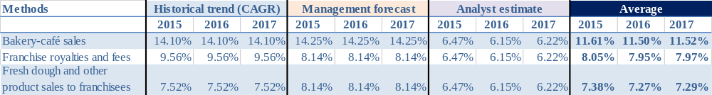

Exhibit 11-11. Revenue amount forecasts for each segment’s revenue and total revenue ($ in thousands)
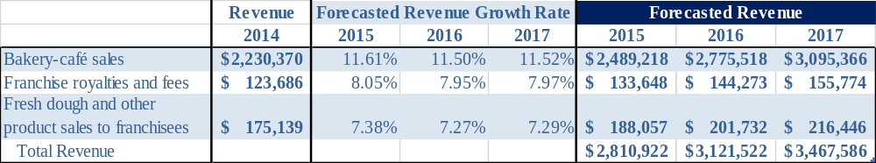

TOPIC 5
PRO FORMA FINANCIAL STATEMENTS ILLUSTRATION

Exhibit 11-12. Panera Bread’s segment revenue CAGR analysis ($ in millions)
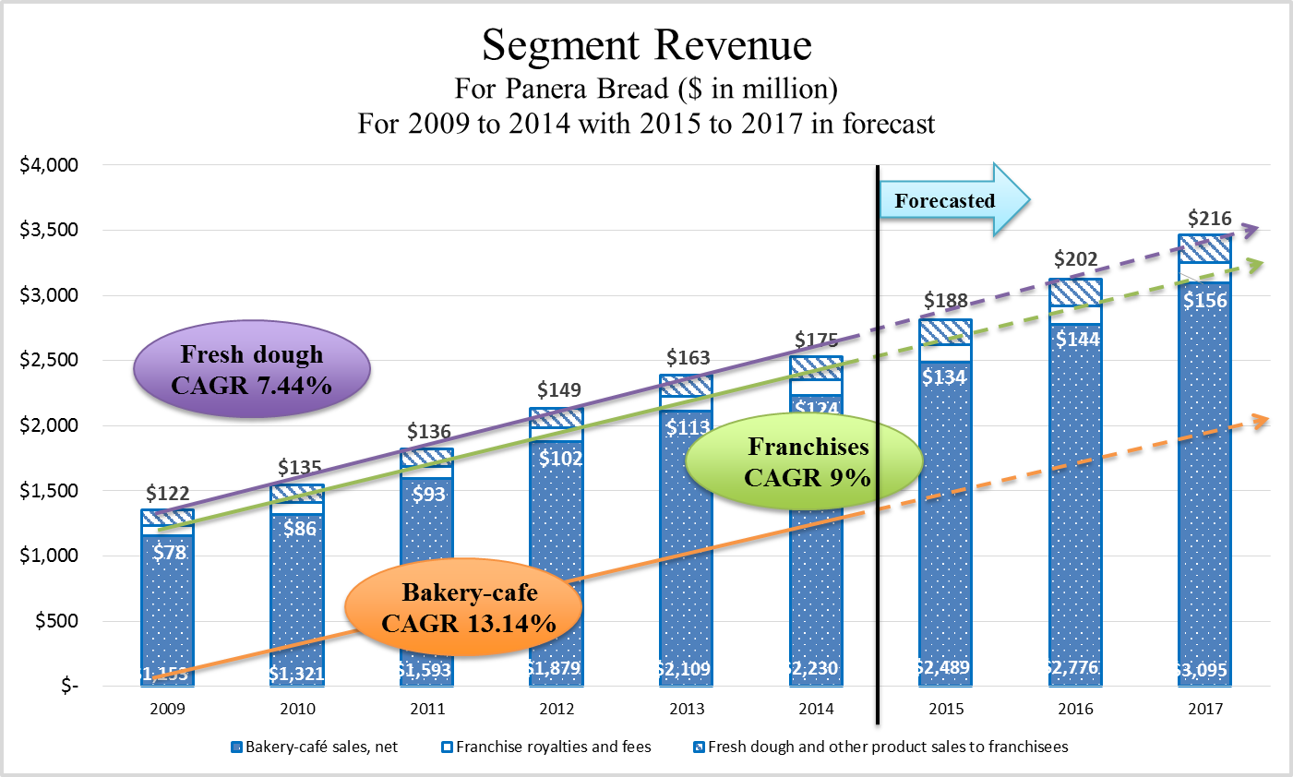

For more advanced revenue prediction, professional judgement is needed in addition to the pure mechanism calculation to identify items such as drivers, risks, and new strategies.
This page is left blank intentionally.

TOPIC 5
PRO FORMA FINANCIAL STATEMENTS ILLUSTRATION

Step 2: Forecast net income.

In this section, we will discuss how to forecast net income by utilizing analysts’ future estimates.

Net income forecasts can be made similarly to how we estimate total revenue. As analysts and research institutions usually provide these estimates directly, we simply use analyst estimates as a reference. Exhibit 11-13 shows net income estimates that we have found from our research.

Exhibit 11-13. Net income growth rate estimates from analysts
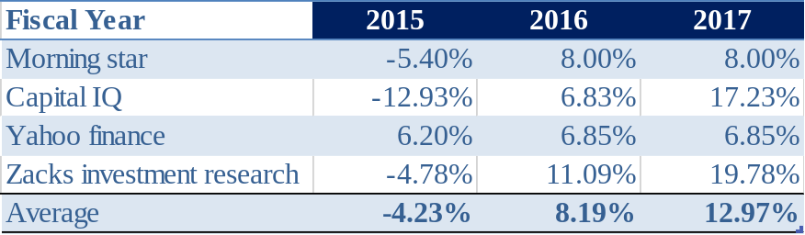

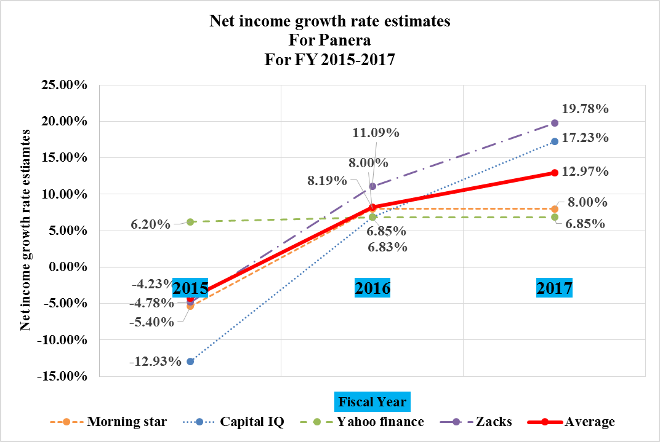

Exhibit 11-14. Forecasted net income ($ in thousands)
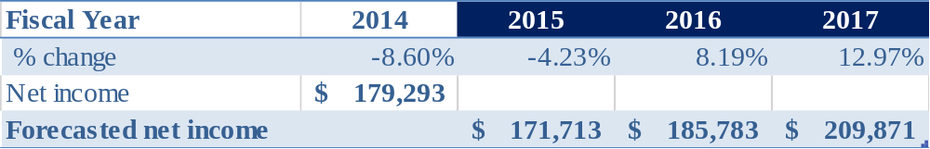

According to analysts, on average, there will be a small decrease of 4.23% in net income in 2015, followed by relatively a sharp increase of 8.19% and 12.97% in 2016 and in 2017 respectively. However, the estimates from the four sources are not part of a consistent manner. Yahoo finance predicts a highest growth of 6.20% in net income for FY 2015, when the other three institutions all predict negative numbers that range from 4.78% to 12.93%. For FY 2016 and 2017, Reuters/Financial time keeps its estimate as almost the same as FY 2015, when the other three institutions’ estimates go up dramatically to even 19.78%.

High diversity in prediction may lead to low reliability. Since we now have no other evident to support or undermine one institution’s estimate, we use an average of four to reach our forecast growth rate: 4.23% decrease in 2015, 8.19% increase in 2016, and 12.97% increase in 2017. With those figures, we can get forecasted net income of $172 million, $186 million, and $210 million in FY 2015, 2016, and 2017 respectively.

TOPIC 5
PRO FORMA FINANCIAL STATEMENTS ILLUSTRATION

Step 3: Forecast Cost of Goods Sold (COGS) for each segment.

In this section, we will discuss how to forecast COGS for each segment, and total COGS.

Among the three segments, franchise royalties and fees segment does not have associated COGS, as this segment does not sell any products to customer and incurs only operating costs. However the other two segments do incur significant amount of COGS.

Forecast Bakery-Cafés Segment COGS

As shown in exhibit 11-15, during the previous five years, the percentage of COGS attributed to bakery-café sales have been kept in a very consistent manner of a little above 67%, with about 29.40% attributed to cost of food and paper products, about 30.46% attributed to labor, and about 7.21% attributed to occupancy, which is rent. Since COGS is linked directly to the volume of revenue both rationally and mathematically, we can infer that COGS is composed primarily of variable costs, and will be a fixed percentage of net sales. Therefore, the historical average of the percentages of COGS attributed to bakery-café sales will be the indicator to predict future related COGS.

Exhibit 11-15. COGS analysis – Bakery-Café segment ($ in thousands)
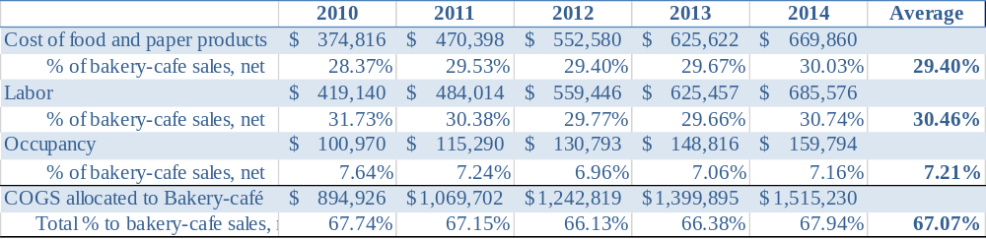

Among all items under COGS within bakery-café segment, cost of food and paper products has been slightly increasing because Panera has been paying more attention to high quality healthy food products and developing more customer package goods. Panera Concepts Essence 2015 "Wellness Ally" and "Craveable Food" continue addressing Panera's focus on food quality and innovations.

Labor has been decreasing slightly from 31.73% to 30.46%, due to the fact that Panera are providing more digital access to customer and thus reducing labor time. Panera has just launched its operations innovations in 2015 that includes Kitchen display system, Speed of service, customer self-ordering systems both online and in store. This initiative will continue to draw down the labor cost in the next three years.

With Cost of food and paper products slightly going up and labor cost slightly going down, COGS to bakery-cafe is able to keep at an average of 67.07%. Since we have determined that COGS is composed primarily of variable costs, and will be a fixed percentage of net sales, we can use the 67.07% as of segment sales to forecast Bakery-café COGS. As exhibit 11-16 shows,
COGS allocated to Bakery-café segment in FY 2015, 2016, and 2017 are $1,669 million, $1,861 million, and $2,076 million respectively based on our forecasted bakery-café sales and the 67.07%.

Exhibit 11-16. Forecasted COGS for Bakery-Café segment ($ in thousands)
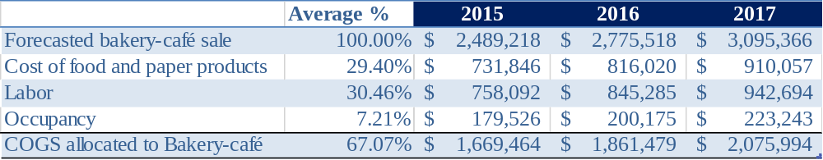

Exhibit 11-17. COGS analysis – Bakery-Café segment ($ in thousands)
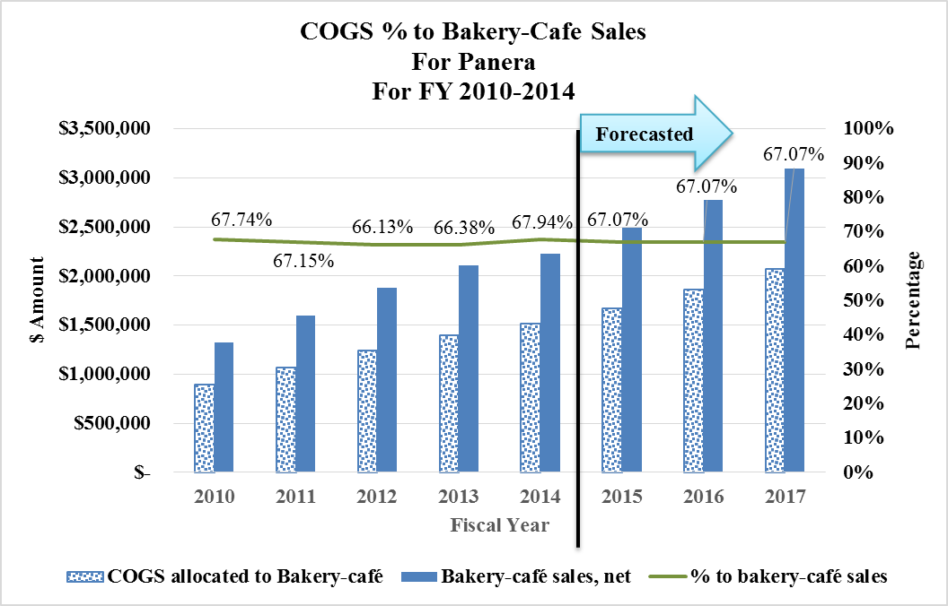

TOPIC 5
PRO FORMA FINANCIAL STATEMENTS ILLUSTRATION

Forecast Fresh dough and other product cost of sales to franchisees segment COGS

Similarly as the COGS analysis for Bakery-Café segment, we have calculated an average COGS percentage for fresh dough and other product costs of sales to franchisees segment to be 85.89% of its segment sale, based on data from FY 2010 to FY 2014. In this segment, the goods shipped is not the final goods to end customers, thus demands fewer services and less general operating costs. Therefore, COGS in this segment constitutes a much higher percentage than the percentage in Bakery-café segment.

Exhibit 11-18. COGS analysis – Fresh dough and other product cost of sales to franchisees segment ($ in thousands)
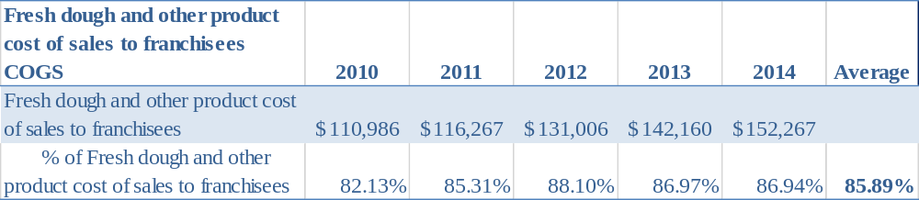

The 85.89% can be utilize to forecast 2015 to 2017 COGS. As calculated in exhibit 11-19, forecasted segment COGS are $162 million, $173 million, and $186 million respectively for FY 2015, 2016, and 2017.

Exhibit 11-19. Forecasted COGS for fresh dough and other product sales to franchisees segment
($ in thousands)
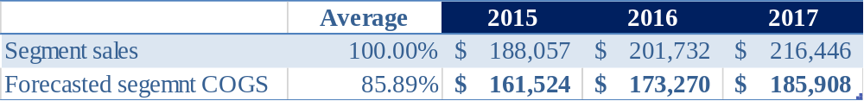

For more advanced revenue prediction, professional judgement is required in addition to the pure mechanism calculation to identify items such as drivers, risks, and new strategy.

Exhibit 11-20. Analysis of COGS for fresh dough and other product sales to franchisees segment
($ in thousands)
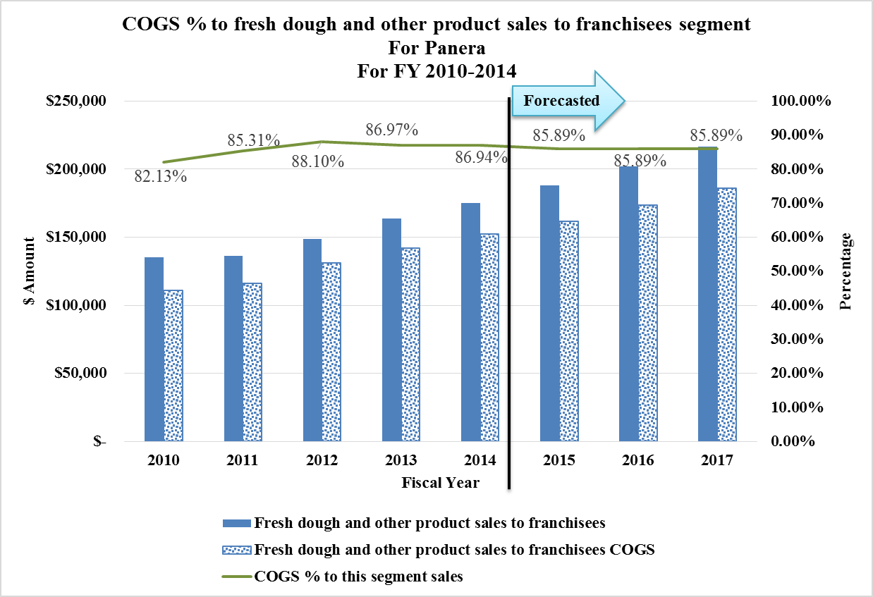

Forecast Total COGS

Exhibit 11-21. Forecasted total COGS.
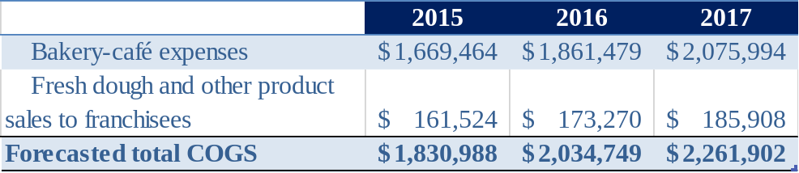

TOPIC 5
PRO FORMA FINANCIAL STATEMENTS ILLUSTRATION

Step 4: Forecast selling, general, and administrative (SG&A) expense.

In this section, we will discuss how to forecast operating expenses, mainly selling, general, and administrative expense. We will also discuss an operating expense item for Bakery-Café segment.

Forecast SG&A expenses

Unlike COGS, SG&A expenses are composed primarily of mixed costs, which remain constant for a certain range of revenue. It appears that Panera Bread’s total revenue has not fluctuated much and generally fall into a similar broad range, so we could forecast SG&A expenses based on SG&A's percentage as of total revenue.

As shown in exhibit 11-22, we can see a consistent while slightly decreasing trend of SG&A's percentage of total revenue. Though the total SG&A expenses are increasing, the percentage of total revenue is actually slightly constantly decreasing. It is due to the reduced labor expenses and improved efficiency with more advanced technology.

Exhibit 11-22. Past SG&A expenses analysis. ($ in thousands) 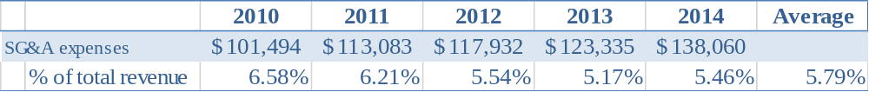
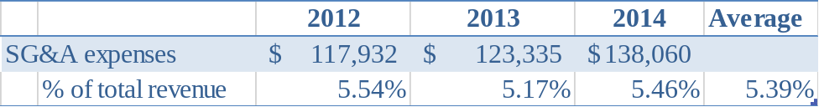

In this specific case of Panera, the method explained previously by using an average of past five years may not be perfect because there is downward trend and it would be more accurate to use a shorter period’s average ratio, such as three year average, to project future SG&A expenses. The management is also working on executing a non-strategic cost reduction reducing general administration costs. We can then forecast a 5.39% SG&A percentage compared to total revenue for the FY 2015 through 2017. Forecasted SG&A expenses can be calculated as forecasted revenue times the 5.39%. Exhibit 11-23 shows the final forecasted results.

Exhibit 11-23. Forecasted SG&A expenses ($ in thousands).
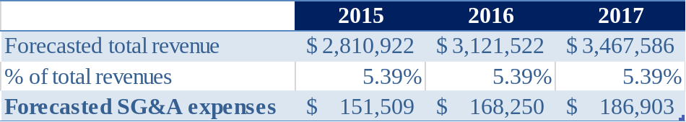
Exhibit 11-24. SG&A analysis ($ in thousands).

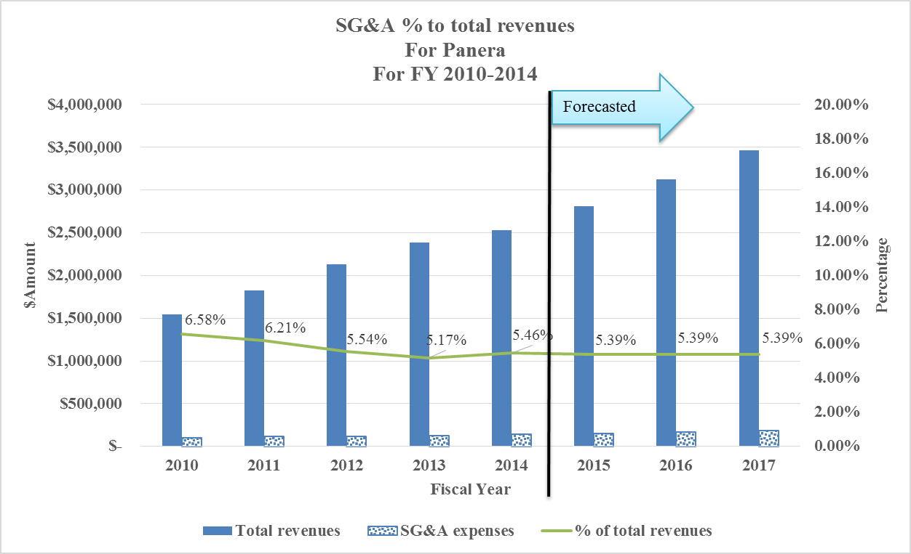

TOPIC 5
PRO FORMA FINANCIAL STATEMENTS ILLUSTRATION

Forecast Bakery-Café Segment SG&A

There is one line item called other operating expenses for Bakery-café expenses. In this part, we will discuss how to forecast this one line item for the next three years.

Similarly to what we have analyzed for general SG&A, we do a percentage analysis to determine the relationship between other operating expenses for Bakery-café expense and its segment revenue. As shown in exhibit 11-25, its percentage has been kept in mid-13% to low 14% range, with a slightly increasing trend. Considering Panera’s effort to reduce operating expenses, which will help keep the slightly increasing trend back to flat, it’s reasonable to use an average of the past five years to forecast for the next three years.

Exhibit 11-25. Past other operating expenses analysis ($ in thousands).
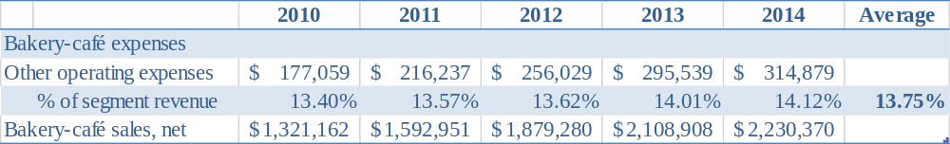

Exhibit 11-26 shows the calculation of forecasted operating expenses for Bakery-café segment, after referring back to the forecasted bakery-café sales. The forecasted other operating expenses under Bakery-Café segment are $342 million, $382 million, and $426 million respectively for FY 2015, 2016, and 2017.

Exhibit 11-26. Forecasted other operating expenses ($ in thousands).
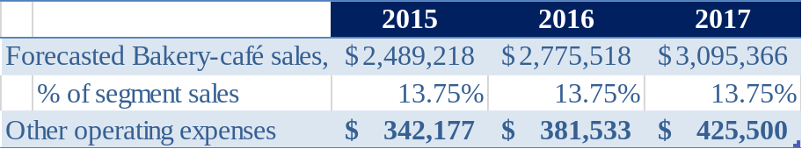

Exhibit 11-27. Analysis of other operating expenses for Bakery-café segment ($ in thousands).

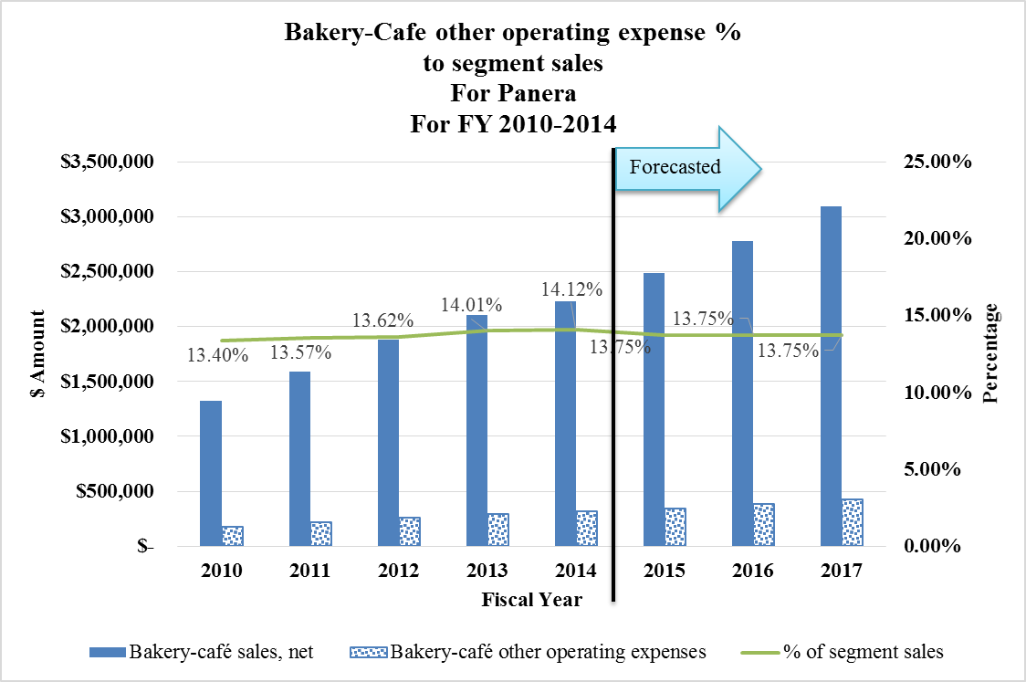
TOPIC 5
PRO FORMA FINANCIAL STATEMENTS ILLUSTRATION

Step 5: Forecast total assets and individual asset items.


In this section, we will discuss how to forecast total assets and individual asset items.

You may wonder why we jump from the income statement to balance sheet when we are only half way through income statement items. I am glad that you have that question!

As you may have realized, numbers on the four financial statements are all interrelated, and one item on one financial statement can impact another item on another financial statement. Figuring out some balance sheet items can give us hints to continue our analysis on income statement; while starting our analysis on the balance sheet also relies on our previous forecast results on income statement items.

For example: the amount of depreciation and amortization (income statement item) is highly related to the amount of property, plant and equipment (balance sheet item); however, it is hard to forecast asset items when forecasted revenue is not available.
Forecast Total Assets

In this section, we will discuss how to forecast total assets.

Total assets prediction relies on a critical ratio, total assets turnover (TAT) that links total revenue, an income statement item, with total assets, a balance sheet item. TAT measures the amount of revenues generated per dollar of assets.
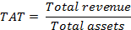

Here, we can use TAT, the relationship between revenue and total assets, to estimate future data. Estimated total assets are calculated by using estimated total revenue divided by estimated TAT ratio. Historical trend analysis is used for Total Assets prediction, and an average of past year ratios is used to forecast future estimates, as shown in exhibit 11-28.

Exhibit 11-28. TAT analysis and total assets forecast.

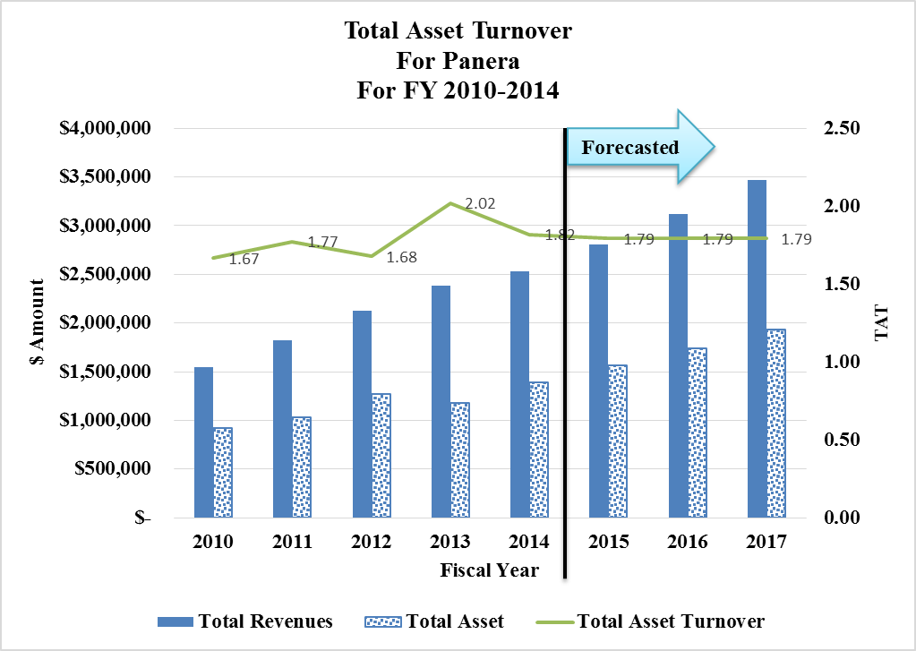

TOPIC 5
PRO FORMA FINANCIAL STATEMENTS ILLUSTRATION

Forecast Individual asset item

In this section, we will discuss how to forecast individual asset item.

After obtaining the forecasted total asset for years from 2015 to 2017, it’s not difficult to forecast each individual asset item, as we can allocate total assets to each individual asset account according to their average percentages as of total assets in the past five years, as shown in exhibit 11-29.

Exhibit 11-29. Individual asset item’s average size to total assets.
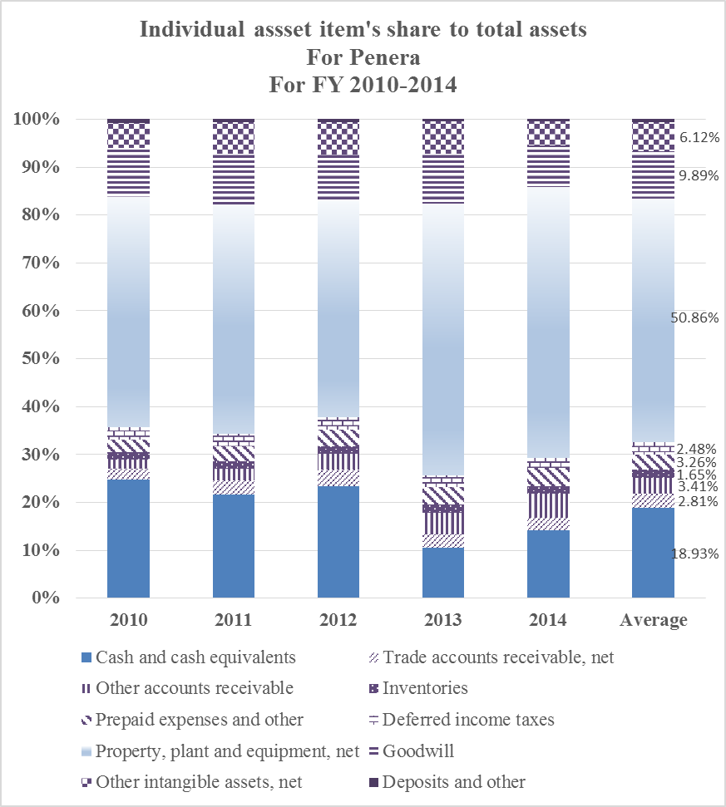

Exhibit 11-30. Individual asset item forecast. ($ in thousands)

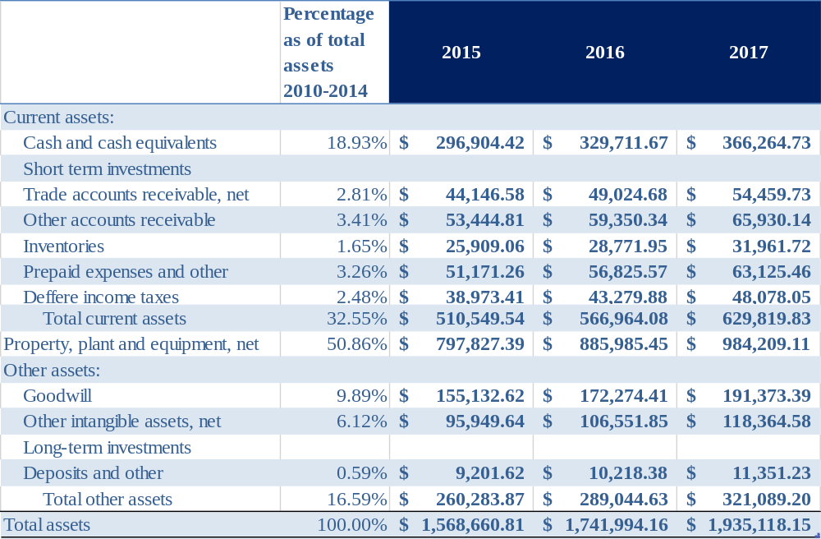
TOPIC 5
PRO FORMA FINANCIAL STATEMENTS ILLUSTRATION

Step 6: Forecast total liabilities and each liability item.

In this section, we will discuss how to forecast total liabilities and each liability item.

Total liabilities

After forecasting total assets, we use a leverage ratio to forecast total liabilities. Exhibit 11-31 shows the trend analysis of the leverage ratio, calculated as total assets divided by total liabilities. The leverage ratio dropped significantly in 2013 and 2014, especially in 2014 when Panera carried a $100 million long-term debt, which increased total liabilities significantly. Therefore instead of using an average leverage ratio for the past five years, we believe that the ratio from 2014 does a better job on predicting the capital structure as the $100 million debt is likely to be on the book for three to five years. So, the 2.12 is then applied to forecast future total liabilities. For the next three years, we could calculate forecast total liabilities as forecasted total assets multiplied by the 2014 leverage ratio of 2.12. Exhibit 11-32 shows the final result on the forecast.

Exhibit 11-31. Average leverage ratio based on data from 2010 to 2014. ($ in thousands)
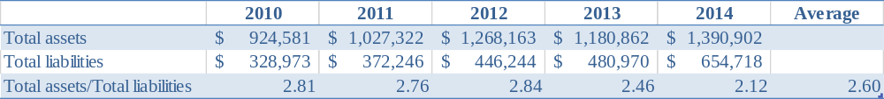

Exhibit 11-32. Forecasted total liabilities. ($ in thousands)
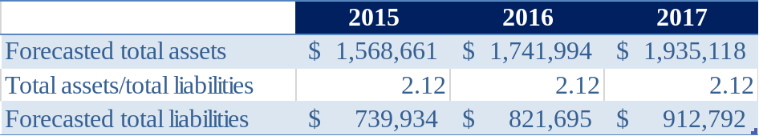

Individual liability item

Similarly to how we forecast individual asset item, we forecast individual lability item by their relative size as of total liabilities according to the past historical data. Similarly to the reason that we use the leverage ratio in 2014, we use the relative size as of total liabilities percentage obtained from 2014 because of Panera’s new liability structure. Exhibit 11-33 shows us how the long-term debt affected the relative size of each item compared to total liabilities in 2014.
Exhibit 11-33. Average relative size as of total liabilities from 2010 to 2014.

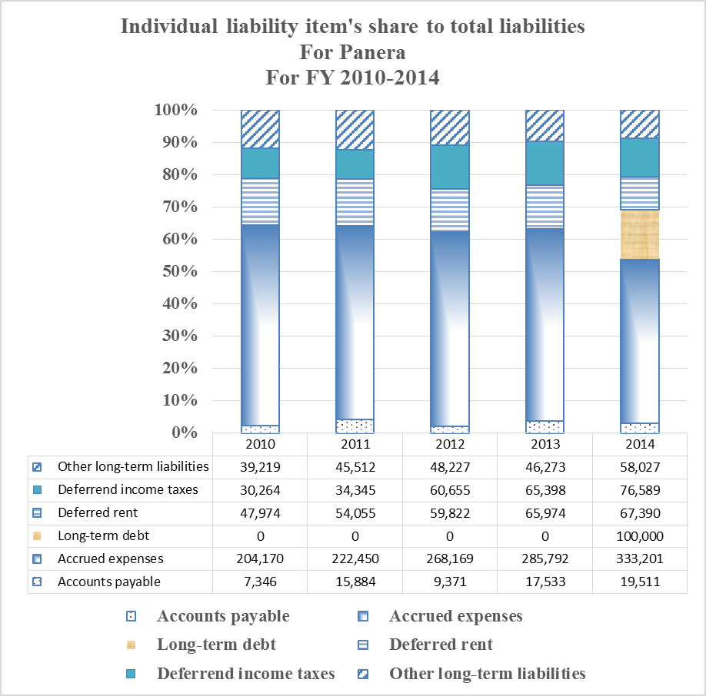

TOPIC 5
PRO FORMA FINANCIAL STATEMENTS ILLUSTRATION

After applying the 2014 relative size to total liabilities, we can forecast each individual liability items by multiplying total forecast liabilities to its average percentage as of total liabilities. Exhibit 11-34 shows the results.

Exhibit 11-34. Forecasted individual liability item ($ in thousands)
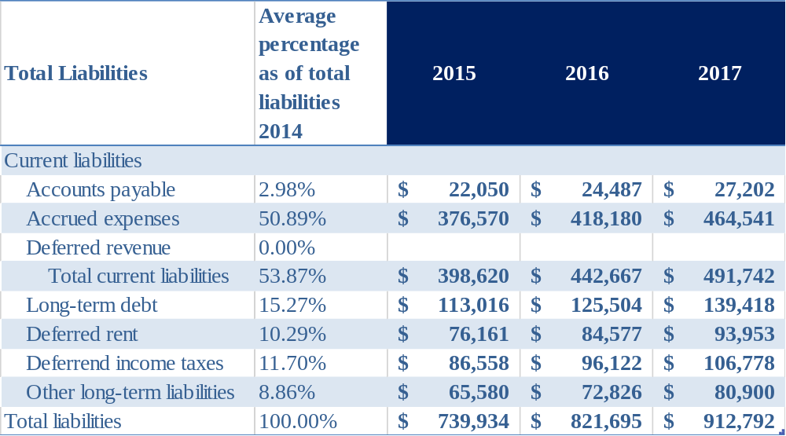
This page is left blank intentionally.
TOPIC 5
PRO FORMA FINANCIAL STATEMENTS ILLUSTRATION

Step 7: Forecast total stockholders’ equity.

In this section, we will discuss how to forecast total stockholders’ equity. There are multiple items to be forecasted in this section, and they usually include common stock, treasury stock, preferred stock, additional paid-in capital, accumulated other comprehensive income (losses), and retained earnings. Exhibit 11-35 shows each item under stockholders’ equity for the past five years.

Exhibit 11-35. Stockholders’ Equity from 2010 to 2014 ($ in thousands).
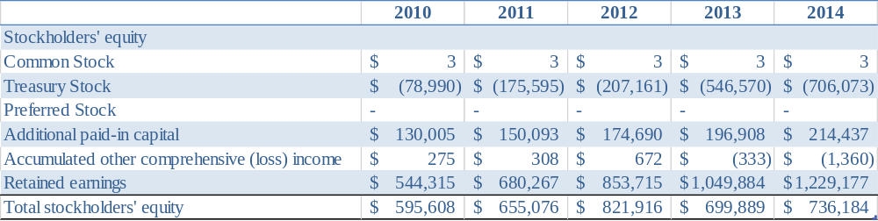

Forecast Common Stock

Common stock has been kept consistently at $3 thousand for the past decade. We predict that it will continue at this level.

Forecast Treasury Stock

Pursuant to the terms of the Panera Bread 1992 Stock Incentive Plan and the Panera Bread 2006 Stock Incentive Plan and the applicable award agreements, Panera has continuously repurchased increasing amount of shares and kept them as treasury stocks for incentive compensation and other purposes. In mid-2014, the Board of Directors approved a new three year shares repurchase authorization of up to $600 million of Class A common stock, with $66.6 million been already repurchased in 2014. There repurchased stocks may be held as treasury stock. We use a five year average for our future three year treasury stock change trend predictions.

Exhibit 11-36. Treasury Stock ($ in thousands)

The forecast for treasury stock for the next three years is $863 million for 2015, $1,020 million for 2016, and $1,176 million for 2017.
Forecast additional paid-in capital (APIC) & accumulated other comprehensive (loss) income

Changes of APIC come from issuance of common stock, exercise of employee stock options, stock-based compensation expense, and the benefit from exercise of stock option. Similarly, we use a five year average for our future APIC and accumulated comprehensive income trend analysis.

Exhibit 11-37. Additional paid-in capital & accumulated other comprehensive (loss) income ($ in thousands)

The forecasted additional paid-in capital & accumulated other comprehensive (loss) income for FY 2015 to FY 2017 are $173 million and $88 thousand respectively.

Forecast Retained Earnings

Retained Earnings are calculated by adding the current year income and subtracting any dividends giving out during current year to the previous year's retained earnings. In the case of Panera, we can see that Panera has not distributed any dividends in the past 10 years, so we could assume dividends giving out to be zero for the next three years. Therefore, we can estimate retained earnings by adding estimating future net income to the previous year retained earnings balance.

As has been shown in Exhibit 11-14 in the Forecast net income section, forecasted net incomes for 2015 to 2017 are $172 million, $186 million, and $210 million respectively.

Exhibit 11-14. Forecasted net income ($ in thousands)

As stated above, for Panera, retained earnings for the current year is simply the retained earnings balance from the previous year plus current year’s net income. Exhibit 11-38 shows results of forecasted retained earnings after including estimated net income for the next three years.

Exhibit 11-38. Forecasted retained earnings.
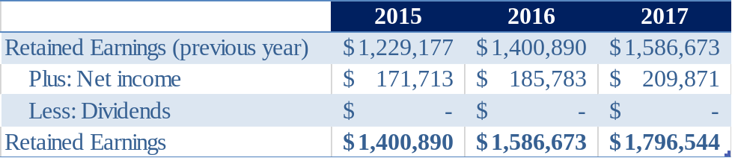

TOPIC 5
PRO FORMA FINANCIAL STATEMENTS ILLUSTRATION

Forecast Total stockholders’ equity

After estimating common stock, treasury stock, preferred stock, additional paid-in capital, accumulated other comprehensive (loss) income, and retained earnings, we could finally get the estimates for total stockholders’ equity by adding up all the items mentioned above. Exhibit 11-39 shows these calculations.

Exhibit 11-39. Forecasted total stockholders’ equity.
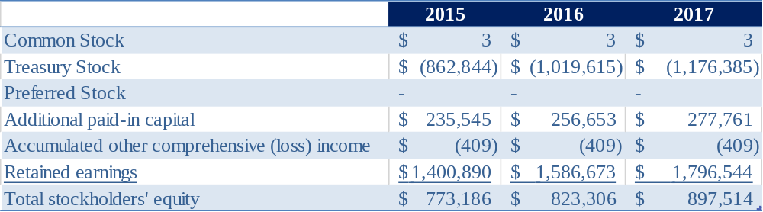

TOPIC 5
PRO FORMA FINANCIAL STATEMENTS ILLUSTRATION

Step 8: Calculate balance sheet plug to close balance sheet.

In this section, we will introduce what a balance sheet plug is for, and how you calculate your balance sheet plug. Balance sheet plug is a special item in the pro forma balance sheet. It is the residual value that connects all other items when they have been forecasted under different methods. A regular balance sheet would not need a balance sheet plug.

Recall what we have done previously: we estimated total assets based on the total asset turnover ratio; we estimated total liabilities based on the leverage ratio; we estimated total stockholders’ equity based on historical average and future net income estimates. It is very likely that total liabilities and total stockholders’ equity do not constitute an exact credit balance to match with the debit balance your estimated total assets provides. In order to balance our pro forma balance sheet, we set up a plug figure to balance up our total assets and the sum of total liabilities and total stockholders’ equity.

Take 2015 as an example, the forecasted total assets are $1,569 million, while the sum of total liabilities and total stockholders’ equity is $1,835 million. The difference of $266 million will be debited to balance sheet plug. Similarly, about $345 million and $436 million will be debited to balance sheet plug for 2016 and 2017 respectively. Exhibit 11-40 shows the results.

Exhibit 11-40. Balance sheet plug ($ in thousands)
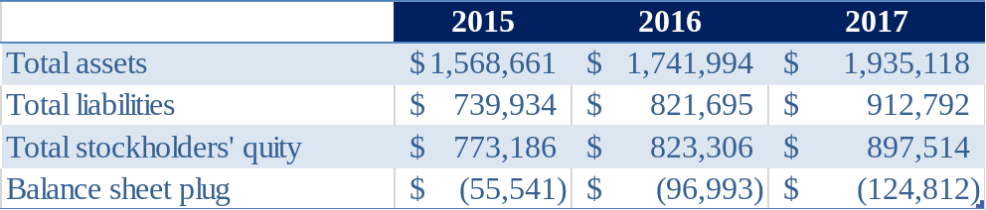

TOPIC 5
PRO FORMA FINANCIAL STATEMENTS ILLUSTRATION

Step 9: Forecast depreciation and amortization expenses.

In this section, we will discuss how to forecast depreciation and amortization expenses.

As you may have already known, depreciation expenses are linked to the amount of your property, plant and equipment (PP&E) and their depreciation methods. Amortization expenses are linked to intangible assets, and they are usually amortized using a straight line method. There are many PP&E and intangible assets in Panera, and it would be not possible for us to dig into each individual item. Therefore, we sum PP&E and other intangible assets as a whole, and figure out their relationship with historical depreciation and amortization expenses for the past five years. Exhibit 11-41 has shown the selected data related to calculations. As can be seen in the last row of exhibit 11-41, the percentage of depreciation and amortization to the sum of PP&E and other intangible assets has been kept in a high 13% to a low 14% range from FY 2010 to FY 2014. This small range confirms our rationale of the relationship between the income statement item - depreciation and amortization expenses, and balance sheet items - PP&E and net intangible assets. Therefore, we could assume that this relationship will apply to the upcoming three years as well.

This relationship is also the reason that we need to forecast some income statement items after we completed our balance sheet forecasts, since those income statement items are dependable on the amount of some balance sheets items.

Exhibit 11-41. Historical information for depreciation and amortization expenses (in thousands)
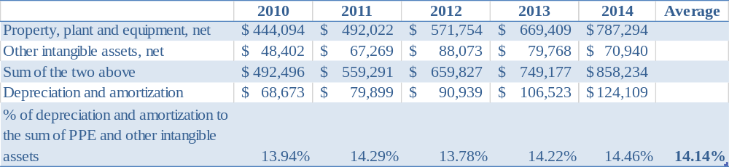

Now we have got the average percentage of depreciation and amortization expenses to the sum of PP&E and other intangible assets from FY 2010 to FY 2014, 14.14%, and forecasted PP&E and other intangible assets for future years 2015, 2016, and 2017. We can easily forecast estimated depreciation and amortization expenses for the next three years. The calculation results have been shown in exhibit 11-42.

Exhibit 11-42. Forecasted depreciation and amortization expenses ($ in thousands)
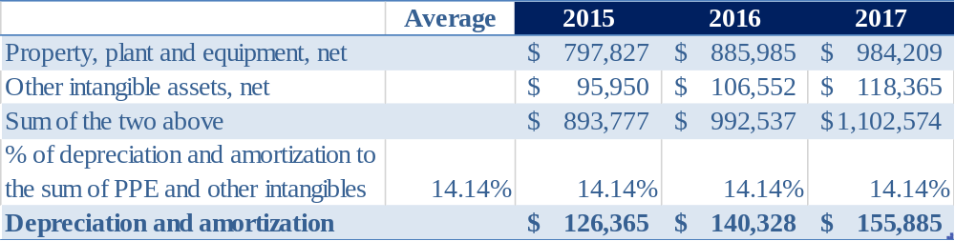

Exhibit 11-43. Analysis of depreciation and amortization expenses ($ in thousands)
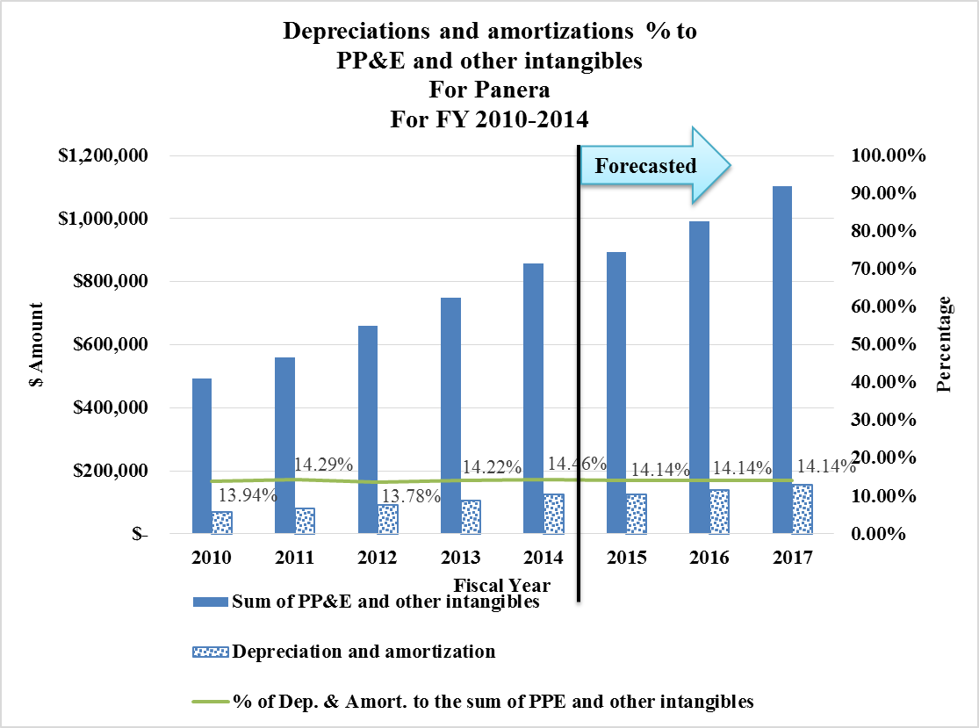
TOPIC 5
PRO FORMA FINANCIAL STATEMENTS ILLUSTRATION

Step 10: Forecast pre-opening expenses.

In this section, we will discuss how to forecast pre-opening expenses.

Exhibit 11-44. Historical pre-opening expenses related data. ($ in thousands)

Pre-opening expenses are directly related to the opening of new bakery-café locations, and pre-opening expenses include pre-opening rent expense, labor, food costs incurred during in-store training, and other preparation expenses. We could conclude that pre-opening expenses link directly with the number of stores opened in each year. In exhibit 11-45, we select necessary relevant data from FY 2009 to FY 2014 to calculate the average number of newly opened stores in each year and pre-opening expenses per store. The number of newly opened franchise stores is not included because those expenses will be carried by franchisees instead of the Panera.

Exhibit 11-45. No. of store opened and pre-opening expense per each store opened from 2010 to 2014. ($ in thousands)
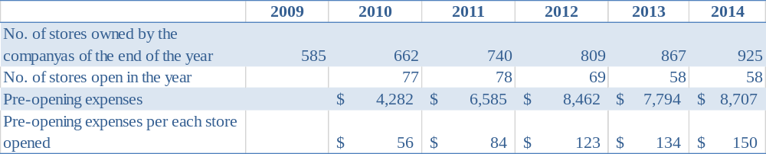

Based on the data from Exhibit 11-45, we can know that the average no. of stores opened in each year from 2010 to 2014 is 61.7, which can be applied to forecast the no. of store that would be opened in the future. Pre-opening expenses having been increasing with the average cost for each store opened increasing as well. Because of the increasing trend, we use the last three years’ data to calculate its increasing rate in each year, which is $14/year. Then, the forecasted pre-opening expense for each store opened for FY 2015 to FY 2017 are $164, $178, and $191 respectively.

Therefore, the forecasted pre-opening expense can be calculated as 61.7, the average no. of stores opened in each year, times the forecasted pre-opening expenses for each store for different years, as shown in exhibit 11-45.

Exhibit 11-46. Forecasted pre-opening expenses. ($ in thousands)
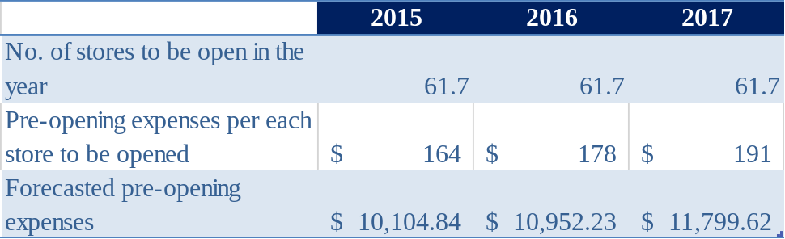

Therefore, forecasted pre-opening expenses for FY 2015 through FY 2017 are about $10.1, $11.0, and $11.8 respectively.
TOPIC 5
PRO FORMA FINANCIAL STATEMENTS ILLUSTRATION

Step 11: Forecast interest expense.

In this section, we will discuss how to forecast interest expenses.

Interest expenses are incurred when long-term debt and other long-term liabilities exist. Using the data from FY 2010 to FY 2014, we can get to know the average percentage of interest expense to the sum of long-term debt and other long-term liabilities. As shown in exhibit 11-47, the percentage of interest expense to the sum of long-term debt and other long-term liabilities ranged from 1.15% to 2.28%, with an average of 1.84%. The recent relatively low rate of 1.15% is due to the new large amount of $100 million long-term debt newly acquired. In the future three years, we assume that there is no big structural change on long-term debt and other long-term liabilities.

Exhibit 11-47. Historical interest expense related information. ($ in thousands)
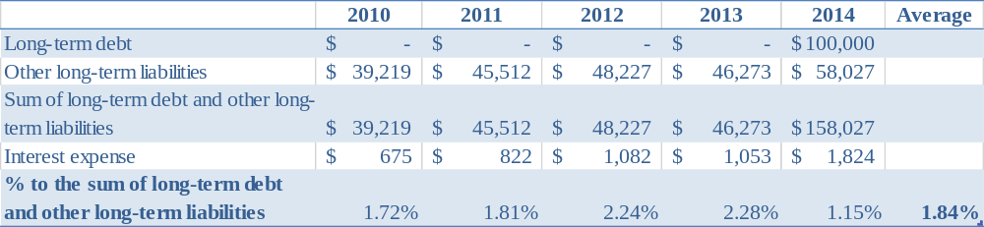

Exhibit 11-48. Historical interest expense related information. ($ in thousands)
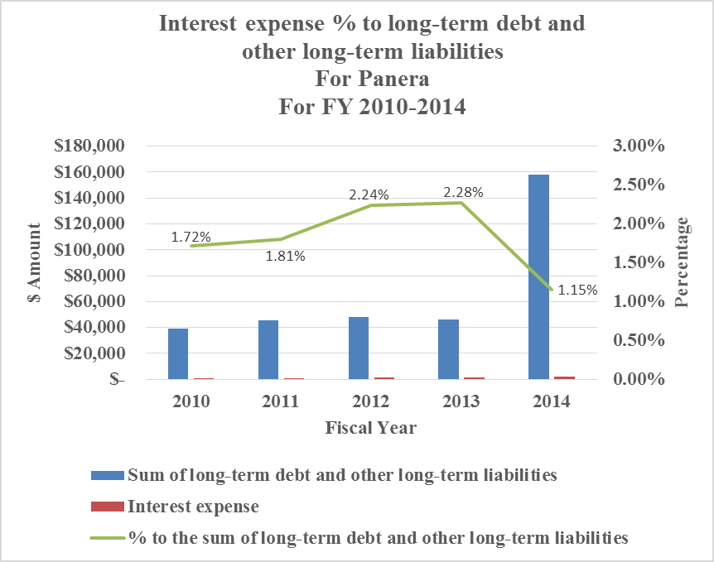
We then apply the average rate of 1.84% to calculate future estimates for FY 2015 to FY 2017 in exhibit 11-49. In conclusion, we forecast interest expense for FY 2015, 2016, and 2017 to be $1,583 thousand, $1,758 thousand, and $1,953 thousand respectively.

Exhibit 11-49. Forecasted interest expense. ($ in thousands)
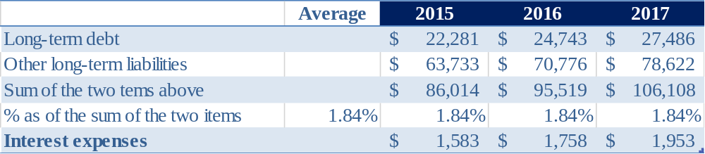

Exhibit 11-50. Analysis of interest expense. ($ in thousands)
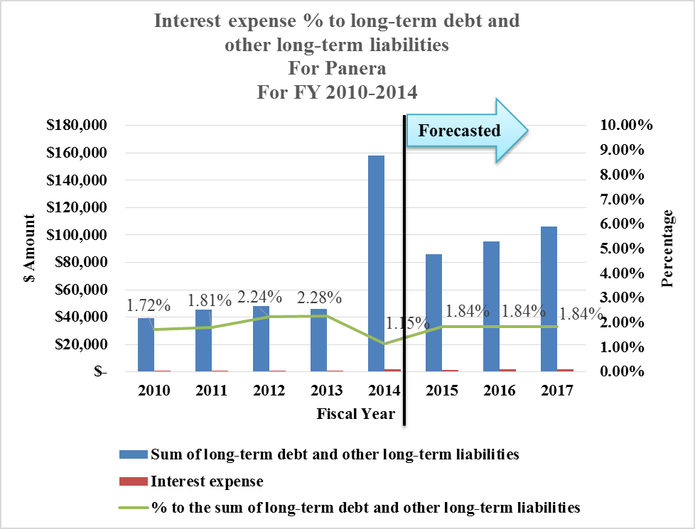
TOPIC 5
PRO FORMA FINANCIAL STATEMENTS ILLUSTRATION

Step 12: Forecast other (income) expense.

In this section, we will discuss how to forecast other (income) expense.

Other (income) expense comes from non-regular or routine operation; instead, it mainly comes from resolution of insurance coverage matters, goodwill impairment charges, resolution of legal matters, and tax issues. Because of the nature of other (income) expense’s unpredictability, we will simply use the average number of the past five years for our estimates for the next three years.

Exhibit 11-51. Historical information for other (income) expense ($ in thousands)

We will forecast other (income) expense for FY 2015 to FY 2017 to be $927 thousand favorable inflow.
This page is left blank intentionally.
TOPIC 5
PRO FORMA FINANCIAL STATEMENTS ILLUSTRATION

Step 13: Forecast income tax expenses and income before income taxes.

In this section, we will discuss how to forecast income taxes and income before income taxes after we have got future net income forecast.

As shown in exhibit 11-52, income taxes are composed primarily of variable expenses, and are linked directly with income before income taxes. The decrease in FY 2014 was driven by discrete income tax benefit items for prior years and an increased deduction for domestic production activities. From FY 2010 to FY 2014, Panera has income taxes as an average of 37.51% of its income before income taxes. Therefore, we will project income taxes as a percentage of income before income taxes. Provided that we have already forecasted future net income, we can now successfully forecast income before income taxes and income taxes, as net income is also a fixed percentage (100%-37.51%=62.49%) of income before income taxes.

Exhibit 11-52. Relationship among income before income taxes, income taxes, and net income. ($ in thousands)
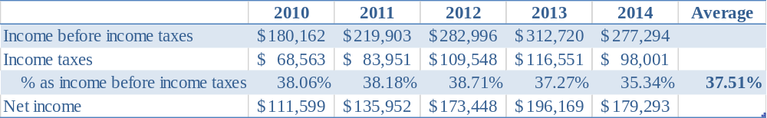

Take FY 2015 as an example, we can get forecasted income before income taxes by dividing the 2015 forecasted net income of $172 million by 62.49%, and forecasted income taxes is the difference between income before income taxes and net income. Same formula can be applied to FY 2016 and FY 2017. Exhibit 11-53 shows forecasted results.

Exhibit 11-53. Forecasts for income before income taxes and income taxes. ($ in thousands)
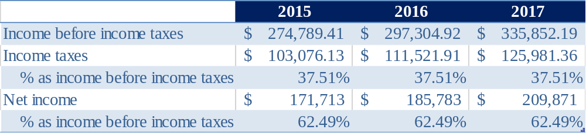

Exhibit 11-54. Analysis of income taxes ($ in thousands).
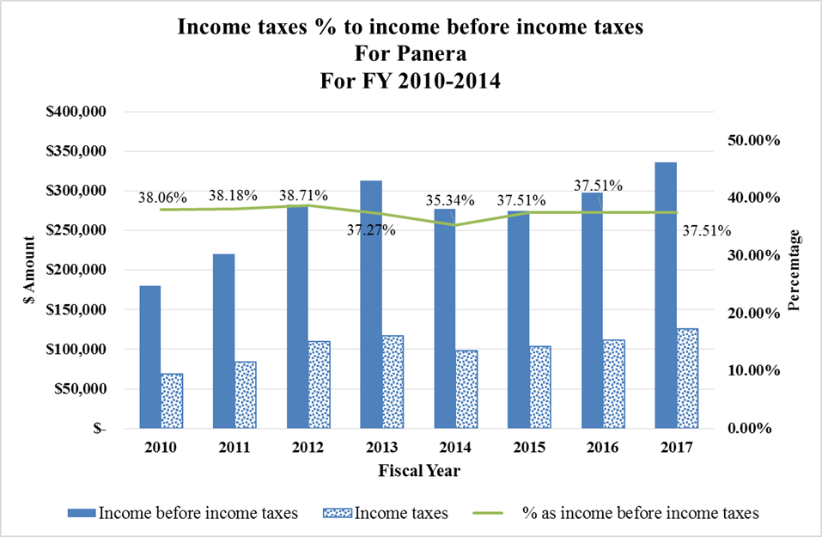
TOPIC 5
PRO FORMA FINANCIAL STATEMENTS ILLUSTRATION

Step 14: Close income statement by including income statement plug.

In this section, we will introduce income statement plug and how to use income statement plug to close your pro forma financial statements.

Recall what we have forecasted previously in steps above: we forecasted revenue based on the information from historical data, management’s prediction, and analyst estimates; we forecasted COGS, SG&A, and some other items based on the forecasted total revenue; we forecasted some other income statement items based on its percentage to related balance sheet items; we also forecasted net income based on analysts’ estimates. Even though we have forecasted all those items based on our best knowledge, those forecasts are completed in different methods. Therefore, it’s very likely that the net income you calculated based on your forecasted income statement items is different from the net income forecasted based on analysts’ estimate that we have obtained in the very beginning. Therefore, we will need to use the income statement plug to fill the gap to balance up the net income as what we have projected.

Exhibit 11-55. Pro forma income statement example.
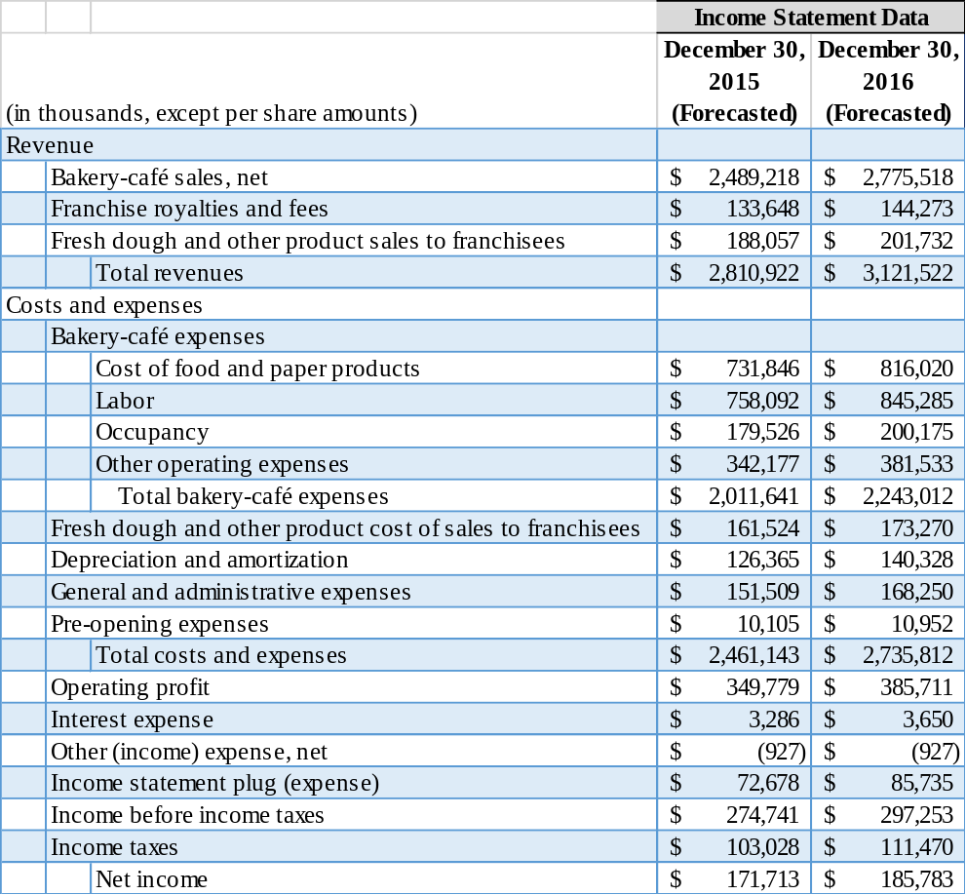

TOPIC 6
RESOURCES FOR ADDITIONAL READING

The purpose of this teaching note is to learn basic concept about pro forma financial statements and to introduce you to the geography of annual reports. The following list provides a few resources you can use to gain additional information.

Accounting and financial statement analysis references:
- The Analysis and Use of Financial Statements by Gerald I. White, CFA, Ashwinpaul C. Sondhi, Ph.D., Dov Fried, Ph.D., John Wiley & Sons, 2003.
- Corporate Finance by Stephen Ross, Randolph Westerfield, and Bradford Jordan, McGraw-Hill/Irwin, 2009.
- Corporate Finance in a Nutshell, 2d (Nutshell Series) by Jeffrey J. Haas, Nutshell Logo and West Group, 2004.
- Crash Course in Accounting and Financial Statement Analysis, Second Edition by Matan Feldman and Arkady Libman, Wall Street Prep Financial Training Solutions, John Wiley & Sons, 2007
- Financial Accounting, Third Edition by Thomas R. Dyckman, Robert P. Magee, and Glenn M. Pfeiffer, Cambridge Business Publishers, 2011
- Financial Reporting & Analysis by Lawrence Revsine, Daniel W. Collins, W. Bruce Johnson, H. Fred Mittelstaedt, McGraw-Hill Irwin, 2009.
- Financial Statements: A step-by-step guide to understanding and creating financial reports by Thomas R. Ittelson, Career Press, 2009.

Ron King.©2017. Thanks to Er Jia Feng, Al Kent, David Pearson, Earl Spiller and Olga Vasilieva for their constructive and helpful assistance.
The term pro forma is sometimes used to refer to financial statements that are prepared in a manner that is not in conformance with GAAP. Such statements, which the SEC refers to as non-GAAP financial statements show financial position and performance as if unusual events that occurred during the period were excluded; these assumed-away events could include items such as restructuring and impairment charges and one-time gains or losses from the sale of a business segment. In such cases, the pro forma financial statements may help investors identify the company’s recurring core earnings and provide a clearer picture of future earnings potential (but alternatively, non-GAAP statements may obscure the information in the reports).
You may also refer to the “Kopolow Business Library” file (found on black board) for additional information resources.
Refer to page 9
Compounded annual growth rate is calculated as (latest revenue/oldest revenue)^(1/(No. of period))-1. 13.32%=($2,529,195/$1,353,494)^(1/5)-1. This formula also applies to other CAGR calculations.
Calculated by (same-store growth rate+1)*(No. of store growth rate +1) -1, which is (1+4.24%)*(1+9.6%)-1=14.25%
Same formula as footnote 4. (1+4.24%)*(1+3.74%)-1 = 8.14%
Morningstar: Obtained in June 2015 http://quicktake.morningstar.com/StockNet/analysisarchive.aspx?docid=697443&year=2015&country=USA&symbol=PNRA Zacks investment research: Obtained in June 2015 http://www.nasdaq.com/symbol/pnra/earnings-growth Capital IQ: Obtained in June 2015 https://www.capitaliq.com/CIQDotNet/Estimates/CIQ/consensus.aspx?CompanyId=252717&dataVendorId=1 Yahoo finance: obtained in June 2015 https://finance.yahoo.com/q/ae?s=PNRA+Analyst+Estimates
According to the management's 2015 annual meeting
Refer to page 39 of Panera’s 2014 financial statements
($150-$123)/2

